**Installing Visual Studio Code:**

1.

I visited this link ([Download Visual Studio Code - Mac, Linux, Windows](https://code.visualstudio.com/Download)) where I downloaded visual studio code for Windows 11. I then run the installer. When the installation process ended, I launch the VS code.

Below is the image of my final output.

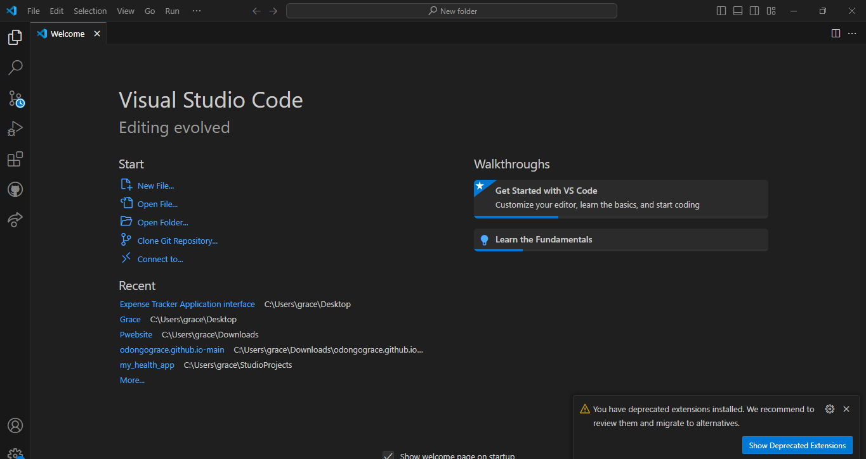

Prerequisites:

* Windows 11 OS.
* Administrator privileges for installation.

2. First-time Setup:

1. Themes
2. Font size
3. Extensions like live server and Prettier for formatting codes.
4. Auto save

3. User Interface Overview:

1. Activity Bar: Located on the far left. Provides access to different views like Explorer, Search, Source Control, Run and Debug, and Extensions.
2. Side Bar: Next to the Activity Bar. Shows different views and panels depending on the activity selected, such as file explorer or search results.
3. Editor Group: The central area where you open and edit your files. You can have multiple editor groups for side-by-side editing.
4. Status Bar: Located at the bottom. Displays information about the current file and workspace, such as the file path, line number, and branch name.

4. Command Palette:

1. The Command Palette in Visual Studio Code is a feature that allows you to perform various tasks efficiently without having to navigate through multiple menus.
2. Command palette can be accessed by pressing the F1 button.
3. The common tasks performed by the command palette are:

* Opening files
* Running build tasks
* Switching themes
* Installing extensions.

5. Extensions in VS Code:

Extensions in VS Code enhances and customizes the functionality of the editor.

How users find and install extensions:

* Open the Extensions view with Ctrl + Shift + X.
* Search for the desired extension.
* Click the Install button.

Managing Extensions:

* Access installed extensions through the Extensions view.
* Disable or uninstall extensions from the context menu.

Examples of Essential Extensions for Web Development:

* Prettier: Code formatter.
* Live Server: Launch a local development server with live reload.

6. Integrated Terminal

Opening and using the terminal

* Go to “View” > “Terminal”

Advantages of using the integrated terminal compared to an external terminal

* Easily switch between coding and terminal tasks.
* Execute commands within the same window.
* Use integrated version control and debugging.

7. File and Folder Management

* Right click on the workspace and select “New File” od “New folder”; this creates a file or a folder
* To open the file, double click on the file name in the explorer view.
* To navigate between different files and directories, use breadcrumbs.

8. Settings and Preferences

* Go to “File” > “Preferences” > “Settings” to find and customize settings.

How to change the theme, font size, and keybindings:

* In Settings, search for Color Theme and select a theme.
* Search for Font Size and set the desired value.
* Go to File > Preferences > Keyboard Shortcuts to modify key bindings.

9. Debugging in VS Code

1. Setting up and starting debugging:

* Click the Run and Debug icon in the Activity Bar to open the debug view.
* Click create a launch.json file link to set up your debug configuration.
* Click the green play button to start debugging

1. Key debugging features

* Breakpoints
* Step over, step into, and step out
* Variable inspection
* Call stack viewing

10. Using Source Control

Initializing a repository

* Open the Source Control view by clicking the Source Control icon in the Activity Bar then click “Initialize Repository”

Making commits

* Stage changes by clicking the + icon next to the files.
* Enter a commit message and click the checkmark icon to commit.

Pushing changes

* Click the ellipsis (...) in the Source Control view and select Push.
* Follow the prompts to log in to GitHub and select the repository.